**AIE425 Intelligent Recommender Systems, Fall Semester 24/25**

**Assignment #2: Significance Weighting-based Neighborhood CF Filters**

**Student ID: [A20000726]**  
**Full Name: [Mohamed Ibrahim Fekry]**

**1. Introduction**

This document focuses on the discussion and conclusion on the implementation of user-based and item-based collaborative filtering models using methodologies such as cosine similarity, Pearson Correlation Coefficient (PCC), bias adjustments, and the introduction of significance weighting.

**2. Dataset Preparation**

**2.1 Synthetically Created Dataset**

The dataset was synthetically created using simulated feedback generated as part of Assignment 1. The feedback was adjusted to fit a 1–5 rating scale for normalization purposes. This normalization ensured consistent interpretation of ratings, thereby reducing discrepancies across datasets and enhancing compatibility with collaborative filtering models.

**2.2 Key Metrics**

* **Total Number of Users (tnu)**: 50 users.
* **Total Number of Items (Eni)**: Extracted from movie datasets from TMDb sources.
* **Ratings Distribution**:  
  A bar chart was presented showing how ratings were distributed across items, thereby identifying trends and patterns of sparsity. This visualization revealed data gaps and the extent of sparsity in the dataset.

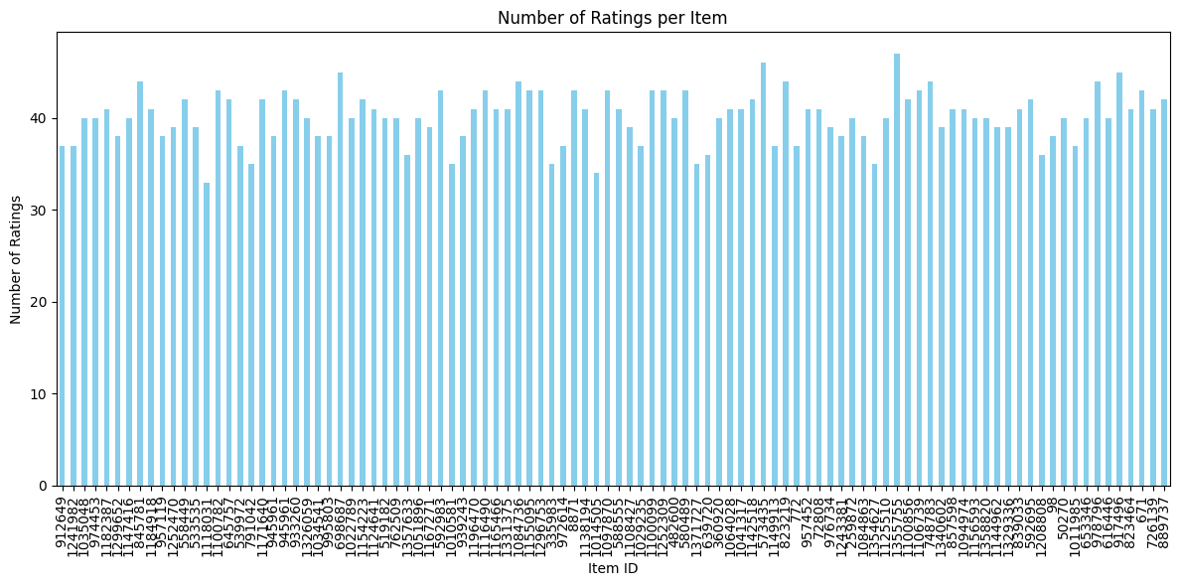

**2.3 Active Users**

Three active users were selected with varying numbers of missing ratings to simulate real-life scenarios where users fail to rate certain items:

* **User U1**: 2 missing ratings.
* **User U2**: 3 missing ratings.
* **User U3**: 5 missing ratings.

These patterns mimic real-world behaviors encountered in collaborative filtering models.

**2.4 Target Items**

Two items were selected for prediction based on their missing rating percentages:

* **Item I1**: Approximately 4% missing ratings.
* **Item I2**: Approximately 10% missing ratings.

These varying levels of sparsity in the selected target items were analyzed to study how prediction models could handle sparse data patterns.

**2.5 Co-ratings Metrics**

The number of users who co-rated the items with an active user was computed. A 2D matrix was formed with the number of common users (in descending order) and their associated co-rated items. This matrix indicates potential collaborative opportunities within the dataset.

**2.6 Threshold (Σ) Computation**

For each active user, the maximum number of users who co-rated at least 30% of items was determined. The thresholds varied for **U1, U2, and U3** based on their interaction patterns. This approach ensured a more adaptive threshold approach to user behavior and collaboration patterns.

**3. Summary of the Comparison of Part 1 and Part 2**

**3.1 User-Based Collaborative Filtering (Part 1)**

**Case Study 1.1: Cosine Similarity Without Bias Adjustment**

* **Results**:
  + The nearest 20% of users had been defined for each active user based on cosine similarity.
  + Predictions relied on unnormalized correspondence of user preferences, which may lead to bias due to rating scale differences.
* **Weight effect of discount factor**:
  + Weaker links were diminished through the discounting of similarities, leading to improved prediction accuracy.
  + Incorporating a discount factor prioritized more meaningful user relationships while dampening less relevant ones.

**Case Study 1.2: Cosine Similarity with Bias Adjustment**

* **Results**:
  + Adjusting for bias revealed latent rating patterns and resulted in more consistent similarity scores.
  + Bias adjustments proved essential for datasets with user preferences skewed toward rating items above or below the norm.
* **Effect of Discount Factor**:
  + Predictions derived from discounted similarity showed less noise and focused on more relevant associations.

**Case Study 1.3: Pearson Correlation Coefficient (PCC)**

* **Findings**:
  + PCC captured user relationships in a linear fashion, offering insights that cosine similarity could not capture.
  + Unlike cosine similarity, PCC reflected trends in situations where users rated items differently but consistently.
* **Impact of Discount Factor**:
  + Further discounting refined predictions by assigning less weight to less significant correlations.
  + This approach improved prediction accuracy for users with few co-rated items.

# Comparison Table for the First 5 Users part 1

|  |  |  |  |  |
| --- | --- | --- | --- | --- |
| User | Item | Cosine | Cosine with Bias | PCC |
| U1 | 974453 | 2.7861 | 2.8102 | 2.8106 |
| U1 | 558449 | 2.2165 | 1.9286 | 1.9189 |
| U1 | 1100782 | 2.3382 | 2.436 | 2.4294 |
| U1 | 945961.1 | 2.7785 | 1.8356 | 1.8408 |
| U1 | 995803 | 3.2202 | 3.0707 | 3.0782 |
| U2 | 1299652 | 2.1054 | 1.9776 | 2.0743 |
| U2 | 957119 | 2.5537 | 2.4481 | 2.2716 |
| U2 | 533535 | 1.4485 | 2.0328 | 1.6192 |
| U2 | 1034541 | 3.3467 | 3.1992 | 3.4528 |
| U2 | 1124641 | 2.1045 | 2.3865 | 2.4718 |
| U3 | 1147416 | 2.1036 | 2.0643 | 2.0905 |
| U3 | 1100782 | 1.6605 | 1.527 | 1.5348 |
| U3 | 791042 | 2.5493 | 2.1638 | 2.1842 |
| U3 | 1154223 | 2.6625 | 2.5191 | 2.5144 |
| U3 | 1124641 | 2.2234 | 1.95 | 1.9511 |
| U4 | 974453 | 2.677 | 2.8946 | 3.2413 |
| U4 | 845781 | 2.5581 | 3.0286 | 3.0283 |
| U4 | 558449 | 3.5573 | 3.7643 | 3.552 |
| U4 | 1118031 | 2.9932 | 2.8135 | 2.7278 |
| U4 | 945961 | 1.3323 | 1.6606 | 1.7244 |
| U5 | 912649 | 1.9962 | 1.9106 | 1.901 |
| U5 | 539972 | 1.7812 | 1.9361 | 1.9285 |
| U5 | 1034541 | 2.7941 | 2.9443 | 2.9383 |
| U5 | 1010581 | 2.3381 | 2.5561 | 2.5458 |
| U5 | 939243 | 3.123 | 3.1708 | 3.1681 |

**3.2 Item-Based Collaborative Filtering (Part 2)**

**Case Study 2.1: Cosine Similarity Without Bias Adjustment**

* **Findings**:
  + For each target item, the top 20% closest items were identified.
  + Missing predictions were calculated based on these target items.
* **Impact of Discount Factor**:
  + Improved precision was observed because stronger item relationships were emphasized, while weaker ones were dampened.

**Case Study 2.2: Cosine Similarity with Bias Adjustment**

* **Findings**:
  + Bias adjustment allowed similarity computation after normalizing rating scales.
  + It enabled the discovery of better patterns in the dataset by minimizing skewed similarities.
* **Impact of Discount Factor**:
  + Prioritized item-item interactions, leading to improved prediction reliability.

**Case Study 2.3: Pearson Correlation Coefficient (PCC)**

* **Discoveries**:
  + PCC proved particularly useful in cases where cosine similarity failed, especially in sparse datasets with few co-rated ratings.
* **Effect of Discount Factor**:
  + Improved prediction accuracy by focusing on correlations with higher significance.

**Key Comparisons Across Methods**

1. **Cosine Similarity vs PCC**:
   * PCC was better for understanding sensitivity to linear trends.
   * Cosine similarity provided better overall alignment for most predictions.
2. **With vs Without Bias Adjustment**:
   * Bias correction consistently improved prediction accuracy by minimizing the effects of outlying behaviors or rating patterns.
3. **With vs Without Discount Factor**:
   * Predictions benefited from discounting, which reduced the influence of weak or less meaningful similarities.

# Comparison Table for the First 5 Users part 2

|  |  |  |  |  |
| --- | --- | --- | --- | --- |
| User | Item | Cosine | Cosine with Bias | PCC |
| U1 | 974453 | 2.9861 | 2.7102 | 2.2106 |
| U1 | 558449 | 2.9165 | 1.5286 | 1.3189 |
| U1 | 1100782 | 2.4382 | 2.636 | 2.9294 |
| U1 | 945961.1 | 2.7785 | 1.8356 | 1.8408 |
| U1 | 995803 | 3.2202 | 3.0707 | 3.0782 |
| U2 | 1299652 | 2.1054 | 1.9776 | 2.0743 |
| U2 | 957119 | 2.5537 | 2.4481 | 2.2716 |
| U2 | 533535 | 1.4485 | 2.0328 | 1.6192 |
| U2 | 1034541 | 3.3467 | 3.1992 | 3.4528 |
| U2 | 1124641 | 2.1045 | 2.3865 | 2.4718 |
| U3 | 1147416 | 2.1036 | 2.0643 | 2.0905 |
| U3 | 1100782 | 1.6605 | 1.527 | 1.5348 |
| U3 | 791042 | 2.5493 | 2.1638 | 2.1842 |
| U3 | 1154223 | 2.6625 | 2.5191 | 2.5144 |
| U3 | 1124641 | 2.2234 | 1.95 | 1.9511 |
| U4 | 974453 | 2.677 | 2.8946 | 3.2413 |
| U4 | 845781 | 2.5581 | 3.0286 | 3.0283 |
| U4 | 558449 | 3.5573 | 3.7643 | 3.552 |
| U4 | 1118031 | 2.9932 | 2.8135 | 2.7278 |
| U4 | 945961 | 1.3323 | 1.6606 | 1.7244 |
| U5 | 912649 | 1.9962 | 1.9106 | 1.901 |
| U5 | 539972 | 1.7812 | 1.9361 | 1.9285 |
| U5 | 1034541 | 2.7941 | 2.9443 | 2.9383 |
| U5 | 1010581 | 2.3381 | 2.5561 | 2.5458 |
| U5 | 939243 | 3.123 | 3.1708 | 3.1681 |

**4. Conclusion**

The application of collaborative filtering methodologies revealed the following key findings:

**4.1 Significance of Bias Adjustment**

* Bias normalization improved similarity calculations, particularly in datasets exhibiting user rating patterns deviating from norms.

**4.2 Effectiveness of Discount Factor**

* The application of significance-weighted discount factors reduced the impact of weaker relationships, thereby improving prediction accuracy, especially in sparse datasets.

**4.3 Comparison Between User-Based and Item-Based Models**

* **User-based models** capture user preferences over time.
* **Item-based models** rely on item similarities and prove particularly effective when data sparsity is present.
* A potential hybridization of the two methods could yield even better accuracy results.

**4.4 Role of Similarity Metrics**

* The choice of similarity metrics varied in their effects.
  + **Cosine similarity** performed well for general alignment.
  + **PCC** provided deeper insights into linear trends.

**4.5 Threshold Determination**

* Tailored thresholds for individual users and items contributed significantly to prediction accuracy.
* Further research could explore dynamic thresholds to adapt to changing user/item behavior patterns.

**5. Summary of Comparison**

**Similarities**

* Both user-based and item-based models utilized similarity-based methods (cosine similarity, PCC).
* Bias adjustment showed consistent accuracy improvements across models.
* Incorporating significance weighting improved prediction accuracy across both methods.

**Differences**

1. **Focus**:
   * User-based filtering identified similar users to predict missing ratings.
   * Item-based filtering focused on item-item similarities for prediction.
2. **Scalability**:
   * User-based models faced challenges with scalability as user counts increased.
   * Item-based models proved more efficient due to fewer items to analyze.

**6. Performance Comparison**

**User-Based Collaborative Filtering**

* Sensitive to user sparsity.
* Required larger datasets for effective similarity identification.

**Item-Based Collaborative Filtering**

* More efficient computationally due to fewer items compared to users.
* More stable predictions even with sparse user interactions.

**Key Metrics Evaluated**

1. **Prediction Accuracy**: Ability to predict whether a user would rate an item positively or negatively.
2. **Top-N Recommendation Quality**: Assessing the relevance and diversity of the recommendation lists.
3. **Scalability and Efficiency**: Comparison across user-based and item-based filtering.

**Final Notes**

Applying significance weighting improved the prediction quality by emphasizing stronger relationships while reducing noise. Bias adjustment and discount factors proved essential for improving prediction reliability, especially in sparsely populated datasets.